REACH Data Unit Officer Test
This test includes three parts, 1. General Knowledge, 2. Data Processing and 3. Coding and dashboard creation. Use the spreadsheets Annex 1 to help you answer the questions below.
The test has been designed to take 2 hours and 30 minutes and examines several competencies regarding data analysis. Read all questions before you begin and note that the three parts can be completed in any order. Aim to attempt every section, but note that we would prefer high quality answers to a few questions (at least one per part), rather than a rushed attempt at all of them. When sending back your answers, please share all scripts, code, files etc. that you used to solve the exercises. Please also list all websites/external sources you used to answer the questions.
All answers can be noted directly on this answer sheet unless otherwise specified. Please return this document with you answers, together with Annex 1 by email.
Part 1: General Knowledge
- Explain p-values in layman terms. Feel free to use analogies or examples. Keep it simple, but make sure to stay technically accurate.
  - Why are they important?
  - How can they be interpreted?
  - What are some common pitfalls/misunderstandings in their use and interpretation?

- When would a Mosaic plot be an appropriate visualization?

- What is personally identifiable information (PII)? Provide an example. When is it ok to collect PII?

Part 2: Data processing
In the spreadsheet Annex 1, you will find a raw dataset from a recent data collection exercise that was carried out by your team.
- There are errors in in the dataset. Please identify at least four errors by highlighting them in yellow in the excel sheets. In the cleaning log tab, report the cell IDs, variable name and a small explanation on why you think this value can be an error in the comment column.
- Using the programming language of R, create a new variable characterizing the household drinking water source into improved / unimproved source following the classification below. Paste the code / function you used below.

Table 3: Unimproved / Improved drinking water source categorization
drinking_water_source | Improved water source
Protected dug well | Improved water source
Piped water to yard or plot | Improved water source
Piped water into dwelling (house) | Improved water source
Bottled water | Improved water source
Tube well or borehole | Improved water source
Public tap or standpipe | Improved water source
Protected spring | Improved water source
Other | NA
Cart with small tank or drum | Unimproved water source
Unprotected dug well | Unimproved water source
Unprotected spring | Unimproved water source
Surface water | Unimproved water source
Tanker-truck | Unimproved water source
Rainwater collection | Unimproved water source

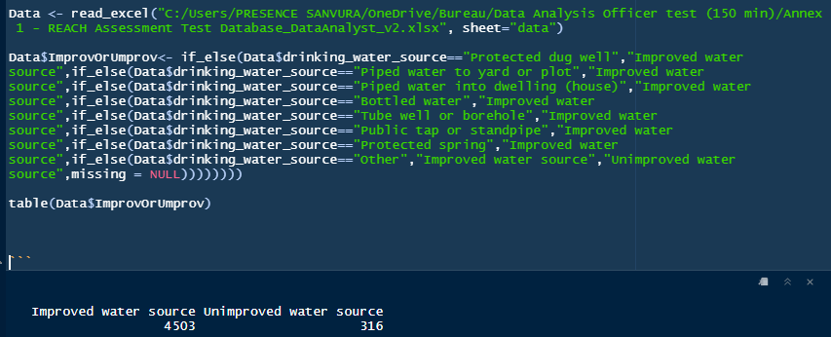

- This exercise requires the results of the previous exercise. Use any tools, statistics and visualizations that you see fit to analyze the questions below regarding how access to improved water sources changed between the baseline (first data collection round) and the endline (second data collection round, after a water improvement project has been implemented). Records for both rounds are in the same dataset; The column “data_collection_round” is “Baseline” for records of the first round, and “Endline” for records from the second round. Please share all code/files used for the analysis.
  - Did single headed households receive more/less improvements? (relevant data column: “single_headed_household”)
  - Did the improvements affect cases of diarrhea in children under 5? (relevant data column: “diarrhea_under_5”)

Part 3: Coding / Dashboard
Instructions
Using the same dataset (Annex 1) create dashboard composed of test statistics and 3-4 graphs to explain changes regarding water and sanitation of households assessed between baseline and end-line. As in all other exercises, please do not forget to include your code as free text including any functions/packages/ sources used to complete this. Bonus points if these are well documented and re-usable.

Complement the graphs with a short interpretation, explaining the main message of your dashboard. Note down any assumptions you made based on the information available.

