Date:
Your name:
Congratulations upon being short-listed for the above position. This is a confidential written test, which will be used to assess some of your qualifications and skills. The objective of the test is to determine whether you can demonstrate that you possess the combination of technical skills, knowledge, and experience for this position.
Please carefully read all instructions below and make sure to follow them.
1. As part of this selection process, this written test exercise should be kept strictly confidential; please do not share it.
2. Candidates should not seek assistance from any other persons in responding to the exercise.
Be sure to save all files with a clear files name. Please remember to include your name on your documents and email them to Hugo Powell - hpowell@immap.org
This technical test is designed to gauge your GIS level and gain a greater understanding of your skills. For this test you will need the following:
- Excel
- A GIS software (QGIS or ArcGIS will work)
- A dashboarding software (PowerBI, Tableau, ArcGIS Online, Google Looker Studio, Shiny Dashboard etc.)
The test should take roughly four hours. Once you have finished, please create a ZIP file with all the maps, packaged project files, and a word document with any links necessary.

Part 1 – 40 Points
You have been recently deployed and your supervisor has requested an update on the following map. Your predecessor has not left any data or information on the contents, so it is up to you to make the update. You can also find a PDF and JPG 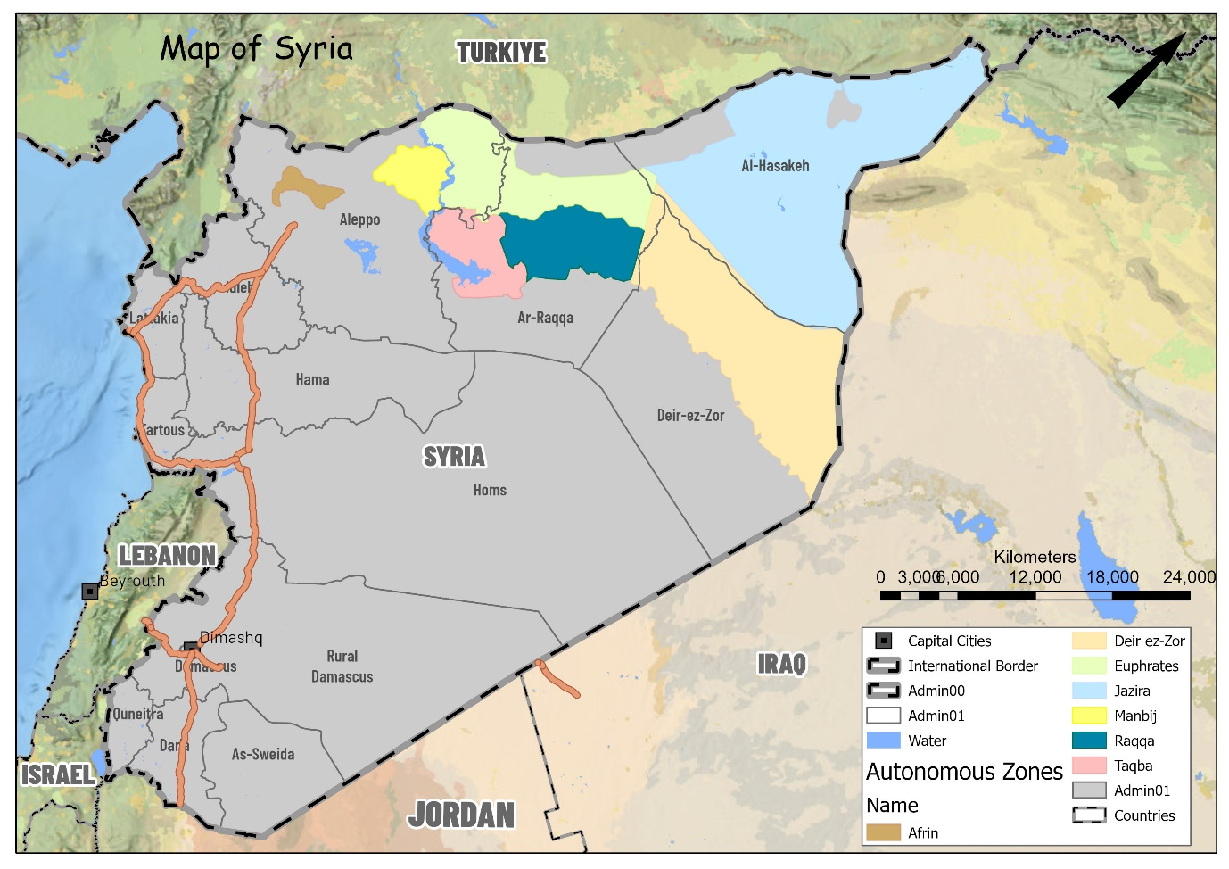
Please re-create this map with your own style and cartographic decisions. Be sure to include all appropriate elements required for an operational map. You must source your own data from wherever you like if the sources are clearly stated. Note: This map contains errors, please identify and change them to be correct.

Part 2 – 40 Points
This exercise will be using the data in the file called: Part 2 – Iraq. You will produce 2 two maps for this exercise. It is up to you how to present and process the data.
Map 1 – Infographic map
- Tidy the shapefile data provided.
- Aggregate the refugee data provided to an Admin01 level – briefly describe your process.
- Using the aggregated data from part b. create an infographic map that highlights refugee concentration at an Admin01 level.
Question 1 – Which Admin01 has the highest concentration of Refugees?
Question 2 – Which GIS tool did you use to aggregate the refugee data to Admin01?

Map 2
- Produce an operations map that highlights which Refugee centres are with 10km of a health site?
Question 1 – How many refugee sites are NOT within 10km of a health site?
Question 2 – Which refugee site is furthest away from a health site and by how many Km?

Part 3 – 20 Points
This exercise will be using the data in the file called: Part 3 – Madagascar. You will produce 1 static dashboard/infographic map displaying the data analysis you will do below. Please see the file named ‘Dashboard infographic example’ to better understand the requirements.
Dashboard
- Calculate the percentage of flooded area at an Admin01 scale – Map
- Calculate the estimated affected populations at an Admin01 scale – Chart
- Please write a short paragraph (max 400 words) to include on the infographic to help people understand the situation.

