Written test for Information System Specialist position

18 April 2022

First Name / Last Name

Regarding multiple-choice questions, only one answer is possible for each, unless a contradictory instruction is explicitly mentioned.

Test duration: 2h

General questions (5 points)
- Enumerate 6 points summing up the main responsibilities of the Information System Specialist? (3 points)

- Enumerate 2 points summing up the required qualities in order to assume the Information System Specialist position? (2 points)

IT technical questions (42 points)
MS Office related questions

- What is the mandatory action to be applied in MS-Word to be able to generate the Table of Contents automatically? (1 point)

- What are the parameters of VLOOKUP function in MS-Excel? (1 point)

- Give two benefits of using Pivot Tables in MS-Excel. (1 point)

Maintenance-related questions

- The different computer components (memory, CPU, peripherals, etc.) are connected via: (1 point)

Put  beside answer(s) | Answer(s)
 | Registry
 | Pointers
 | Operating system
 | Bus

- What is the command, to be applied in Windows, in order to open the Registry Editor? (1 point)

- What is a System Restore Point under Windows and what is its purpose? (1 point)

- What is a Ghost Image of Windows and what is its purpose? (1 point)

- Give three symptoms of failed RAM? (1 point)

- Give two factors to be considered when adding/combining extra RAM sticks? (1 point)

- Give three physical and logical means to protect user’s data. (3 points)

Networking questions

- What is the command, to be applied in Windows, in order to get IP addresses of all Network Interface Cards? (1 point)

- Give four protocols that are/could be used to receive emails? (2 points)

- Which protocol is used to send emails? (1 point)

Put beside answer(s) | Answer(s)
 | NNTP
 | XDMA
 | SMTP
 | POP3
 | FTP

- The following string “CC:B2:82:BG:53:B7” represents : (1 point)

Put beside answer(s) | Answer(s)
 | MAC address
 | Port number
 | IP address
 | SAP number

- Regarding Ethernet Hubs and Switches, which of the following statement is true? (1point)

Put beside answer(s) | Answer(s)
 | A Hub is faster than a Switch
 | Inbound data on one Hub port are broadcasted to all other Ports
 | A Switch has been originally designed to route traffic among different networks
 | 10, 100 mbps / 1gbps Hubs Ports function simultaneously which is not the case for Switch Ports

- Which network service allows to associate names to IP addresses? (1 point)

Put beside answer(s) | Answer(s)
 | DHCP
 | FQDN
 | BOOTP
 | WINS
 | DNS

- Which network service allows to automatically distribute IP addresses to network devices? (1 point)

Put beside answer(s) | Answer(s)
 | BOOTP
 | DHCP
 | TCP
 | UDP
 | IGMP

- What is a LAN? (1 point)

Put beside answer(s) | Answer(s)
 | Is a new standard to remotely access V92 Modems
 | Is a local network
 | Is a cable connecting two Ethernet cards
 | Is a remote access to Enterprise network

- Which server allows to store locally the visited web pages in order to provide them quickly for the users when these pages will be consulted again? (1 point)

Put beside answer(s) | Answer(s)
 | WINS
 | DNS
 | PROXY
 | WEB

- In a working environment where the use of the Internet connection is mainly done by Office applications (web browsing, email, Teams, videoconferencing, collaborative tools, shared folder via a Cloud service), what are the quotas that you dedicate for Download and Upload traffic assuming that the total bandwidth is 5 mbps? (1 point)

Put beside answer(s) | Answer(s)
 | 3.5 for Download and 1.5 for Upload
 | 1.5 for Download and 3.5 for Upload
 | 5 for Download and 0 for Upload
 | Others. Specify quotas:

- Regarding WAN connections, which of the following statements are true? Multiple answers are possible. (2 points)

Put beside answer(s) | Answer(s)
 | 3G/4G connections can only be dedicated connections
 | ADSL connections can only be asymmetric connections
 | VSAT connections could be dedicated and symmetric
 | VSAT connections could be shard and asymmetric

- Assuming a WAN connection with 3 mbps Download/1 mbps Upload, based on the following bandwidth charts which are produced by the Client Firewall regarding the concerned WAN, which of the following statement is true? (2 points)
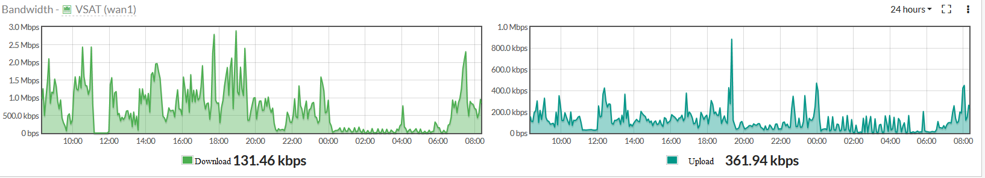

Put beside answer(s) | Answer(s)
 | The ISP doesn’t respect its bandwidth engagement during the last 24 hours
 | The ISP respects its bandwidth engagement during the last 24 hours
 | The first two statements are not able to be verified with the following charts because they are produced by the Client Firewall and not the ISP one
 | The first two statements are not able to be verified based only on the following charts

- By analyzing the following ping results, which interpretation could you make, knowing that 151.101.52.81 is the IP address of the www.bbc.com site? (2 points)

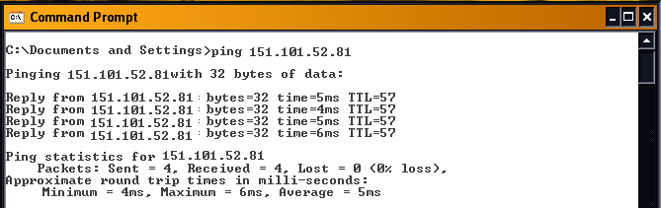
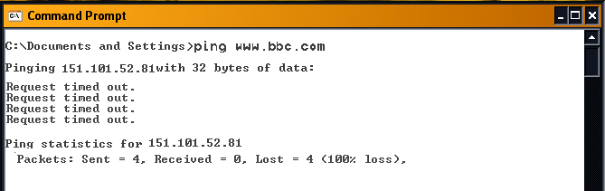

- Regarding VPN, which of the following statements are true? Multiple answers are possible. (1 point)

Put beside answer(s) | Answer(s)
 | A VPN is a tunnel to encrypt exchanged data between two points in a secure manner over a LAN
 | A VPN is a tunnel to encrypt exchanged data between two points in a secure manner over a non-secure network
 | A VPN allows mobiles users to access the internal IT resources of their Enterprise remotely
 | All previous statements are false

Data base-related questions

Assume a Customers table being created using the following SQL statement and filled out as shown in Table 1.

CREATE TABLE Customers (
CustomerID int NOT NULL,
CustomerName varchar(255) NOT NULL,
City varchar(255) NOT NULL,
Country varchar(255) NOT NULL,
PRIMARY KEY (CustomerID)
);

Table 1 Customers Table
CustomerID | CustomerName | City | Country
1 | Maria Anders | Berlin | Germany
2 | Ana Trujillo | México | Mexico
3 | Antonio Moreno | México | Mexico
4 | Thomas Hardy | London | UK
5 | Christina Berglund | Lulea | Sweden
6 | Hanna Moos | Mannheim | Germany
7 | Frédérique Citeaux | Strasbourg | France
8 | Martín Sommer | Madrid | Spain
9 | Laurence Lebihans | Marseille | France
10 | Elizabeth Lincoln | Tsawassen | Canada
- What is the result of applying the following SQL statement on the Customers table? (1 points)

INSERT INTO Customers (CustomerID, CustomerName, City, Country)
VALUES ('2', 'Maria Anders', 'Berlin', 'Germany');

Put beside answer(s) | Answer(s)
CustomerID | CustomerName | City | Country
1 | Maria Anders | Berlin | Germany
2 | Maria Anders | Berlin | Germany
3 | Antonio Moreno | México | Mexico
4 | Thomas Hardy | London | UK
5 | Christina Berglund | Lulea | Sweden
6 | Hanna Moos | Mannheim | Germany
7 | Frédérique Citeaux | Strasbourg | France
8 | Martín Sommer | Madrid | Spain
9 | Laurence Lebihans | Marseille | France
10 | Elizabeth Lincoln | Tsawassen | Canada

CustomerID | CustomerName | City | Country
1 | Maria Anders | Berlin | Germany
2 | Ana Trujillo | México | Mexico
3 | Antonio Moreno | México | Mexico
4 | Thomas Hardy | London | UK
5 | Christina Berglund | Lulea | Sweden
6 | Hanna Moos | Mannheim | Germany
7 | Frédérique Citeaux | Strasbourg | France
8 | Martín Sommer | Madrid | Spain
9 | Laurence Lebihans | Marseille | France
10 | Elizabeth Lincoln | Tsawassen | Canada

CustomerID | CustomerName | City | Country
1 | Maria Anders | Berlin | Germany
2 | Ana Trujillo | México | Mexico
2(1) | Maria Anders | Berlin | Germany
3 | Antonio Moreno | México | Mexico
4 | Thomas Hardy | London | UK
5 | Christina Berglund | Lulea | Sweden
6 | Hanna Moos | Mannheim | Germany
7 | Frédérique Citeaux | Strasbourg | France
8 | Martín Sommer | Madrid | Spain
9 | Laurence Lebihans | Marseille | France
10 | Elizabeth Lincoln | Tsawassen | Canada

- What is the result of applying the following SQL statement on the Customers table? (2 points)

SELECT COUNT( "CustomerID" ), "Country"
FROM "Customers"
GROUP BY "Country"
HAVING COUNT( "CustomerID" ) > 1

Virtualization-related questions

- Which of the following statements are true? Multiple answers are possible. (1 point)

Put beside answer(s) | Answer(s)
 | The Virtualization is a Windows simulation
 | The Virtualization is a Linux simulation
 | The Virtualization is running a Guest OS on top of a Hypervisor
 | The Virtualization reduces costs linked to the Hardware investments

- Gives 3 softwares that allow us to make hypervisor (1 point)

Use case

Network description

MSF network is extended over two sites: Office and Hospital. Both sites are interconnected via a WIFI bridge using Ubiquiti Nano Stations.

Office segment is constituted of a dual WAN Firewall (where the WAN connection is plugged), a Switch (SW_01), a network printer (Print_01), WIFI Access Point (AP_01), four computers (COMP[01-04]) and a Nano Station (NS_01).

Hospital segment is constituted of a Switch (SW_02), a network printer (Print_02), WIFI Access Point (AP_02), three computers (COMP[05-07]) and a Nano Station (NS_02).

WIFI Access Points, printers and Nano Stations have fixed IP addresses and don’t belong to the IP range of the DHCP Server. Contrariwise, computers IP addresses have to be distributed by the DHCP Server.

The IP range of the DHCP Server is between 10.234.1.30.and 10.234.1.254

Both segments belong to one subnet (10.234.1.0/24); no VLAN should be used in the corrective actions.

Questions (see appendix page 14)

- There is a problem regarding the applied DHCP configuration. Identify the problem and enumerate the corrective action(s) to resolve it. (2 points)

- In order to restrict the access to the Office and Hospital network, a MAC Filtering is applied on the Firewall. There are two problems regarding the applied MAC Filtering configuration. Identify both problems and enumerate the corrective actions to resolve them. (3 points)

- Assuming that there is a good 4G coverage in the Office/Hospital neighborhood, and in order to provide a backup connection for the whole network, how many 4G subscriptions would you subscribe for? Where would you connect your 4G routers? (2 points)

Additonal questions (5 points)

- Which class of IP address does the following address belong to ?: 129.192.168.2 (1 point)

C.
D.
- How can you force a client to give up a DHCP lease IP, provided you have access to the machine? What command do you then run to get a new IP address? And what command can you use to remove saved DNS cache (1 point)

- What do you know about Microsoft Azure? (1 point)

- Which command allows to modify the access rights on files or directories Linux ? (1 point)

- Chown
- Mod
- Chmod
- Att[options]

- The Sudo command Lunix allows you to : (1 point)

- enables users to Change directory
- enables users to Create directory
- enables users to run programs with the security privileges
- enables users to have access to directory

Appendix: MSF network Topology
